Dr. Sachchidanand Sinha

Revenue Concept
Revenue, in simple words, is the amount that a firm receives from the sale of the output. According to Prof. Dooley, ” The Revenue of a firm is its sales receipts or income.‘ In a firm, revenue is of three types:
1. Total revenue
2. Average revenue
3. Marginal revenue
Total Revenue
This is simple. The Total Revenue of a firm is the amount received from the sale of the output. Therefore, the total revenue depends on the price per unit of output and the number of units sold. Hence, we have
TR = Q x P
Where,
- TR – Total Revenue
- Q – Quantity of sale (units sold)
- P – Price per unit of output

Average Revenue
Average Revenue, as the name suggests, is the revenue that a firm earns per unit of output sold. Therefore, you can get the average revenue when you divide the total revenue with the total units sold. Hence, we have,
AR ={TR}\ {Q} ​
Where,
- AR – Average Revenue
- TR – Total Revenue
- Q – Total units sold

Marginal Revenue
Marginal Revenue is the amount of money that a firm receives from the sale of an additional unit. In other words, it is the additional revenue that a firm receives when an additional unit is sold. Hence, we have
MR = TR_{n} – TR_{n-1}
Or
MR ={ΔTR}\ {ΔQ} ​
Where,
- MR – Marginal Revenue
- ΔTR – Change in the Total revenue
- ΔQ – Change in the units sold
- TR_{n} – Total Revenue of n units
- TR_{n-1} – Total Revenue of n-1 units
MR pertains to a change in TR only on account of the last unit sold. On the other hand, AR is based on all the units that the firm sells. Therefore, even a small change in AR causes a much bigger change in MR. In fact, when AR reduces, MR reduces by a far greater margin.
Similarly, when AR increases, MR increases by a greater extent too. AR and MR are equal only when AR is constant. It is also important to note that the firm does not sell any unit if the TR or AR becomes either zero or negative. However, there are times when the MR is negative (especially if the fall in price is big).

The relationship between TR, AR, and MR
In order to understand the basic concepts of revenue, it is also important to pay attention to the relationship between TR, AR, and MR. When the first unit is sold, TR, AR, and MR are equal.
Therefore, all three curves start from the same point. Further, as long as MR is positive, the TR curve slopes upwards.
However, if MR is falling with the increase in the quantity of sale, then the TR curve will gain height at a decreasing rate. When the MR curve touches the X-axis, the TR curve reaches its maximum height.
Further, if the MR curve goes below the X-axis, the TR curve starts sloping downwards.
Any change in AR causes a much bigger change in MR. Therefore, if the AR curve has a negative slope, then the MR curve has a greater slope and lies below it.
Similarly, if the AR curve has a positive slope, then the MR curve again has a greater slope and lies above it. If the AR curve is parallel to the X-axis, then the MR curve coincides with it.
Here is a graphical representation of the relationship between AR and MR:
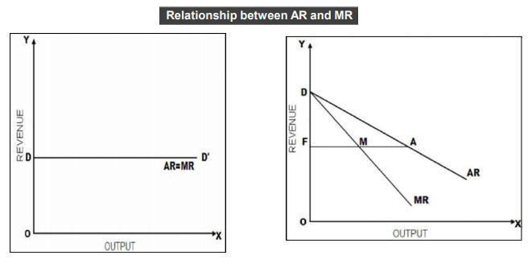
In the left half, you can see that AR has a constant value (DD’). Therefore, the AR curve starts from point D and runs parallel to the X-axis. Also, since AR is constant, MR is equal to AR and the two curves coincide with each other.
In the right half, you can see that the AR curve starts from point D on the Y-axis and is a straight line with a negative slope. This basically means that as the number of goods sold increases, the price per unit falls at a steady rate.
Similarly, the MR curve also starts from point D and is a straight line as well. However, it is a locus of all the points which bisect the perpendicular distance between the AR curve and the Y-axis. In the figure above, FM=MA.

