Dr. Surendra Kumar
Technology & Economic Development
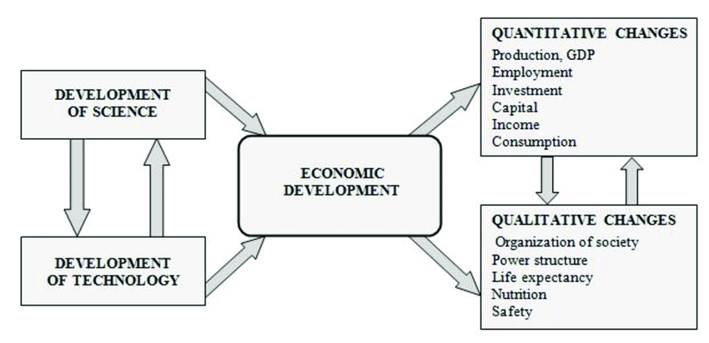
Economic development of all countries of the world. Economic development depends on number of factors. Technology for economic development of any country is an important factor. All developed and under developed countries economy, agriculture, industry, transport, banking, health, education and improved technology in all sectors are trying to install.
Meaning of technology
Technology equipment and services for the production of economic resources or technologies that facilitate learning.
Adoption of technology
Technology and developing countries by developed countries may not adopt product. Major markets of advanced industrial countries, high income, ample capital resources, supported by good management and technical skills are the least developed countries, small income, capital shortages, unskilled labor is abundant. Advance technology, so, what can be done for these countries. Developing countries should adopt appropriate technology to provide the needed employment is based. The development stage of the country’s current economic policy framework should be within.
Importance of Technology
Technology is important due to following reason:-
Increase in labor productivity
With labor productivity growth in the use of technology. If we help the agricultural sector, for example, a farmer with tractor can work more than ten farmers.
More human capital
Human capital means skilled and educated labor force when we increase the use of technology the skills in labor also increase; it leads to human capital formation.
Providing better living standard
We enjoy living facilities per capita income and the quality of life decision. Technology, national income and per capita income growth using, is it leads to better quality of life.
Output increases
As labor productivity increases the production level increase of country. This cause increase in national income of a country.
Rapid increase in supply
According to Keynes rapid increase in supply is possible with the help of technology. If demand of a commodity increase, it is possible to match the demand with the help of technology. It removes the danger of inflation.
Trade
The basis of international trade is “a country exchanges its excess production with the excess production of another country”. So with the use of technology production and international trade also increase.
Advancement in infrastructure
Technology itself is the component of infrastructure. with the use of advancement in technology we can improve .such as use of atomic energy, use of gas in place of petrol, and computer e.t.c
No wastages of resources
Technology helps in removing wastages of resources in production. It is possible to have more output with same inputs in the presence of technology.
Cost minimizing
According to tha Gallbraith “The increasing use of technology in a society as the efficiency increases. growth of national income and expense control in results
Economics of scale
It means that advantages are attached with high production level.in this modern era we know that the use of technology production will increase as a result cost will decrease and profit will increase.Find out more
Overcome vicious circle of poverty.
With the use of technology income of the country increase. When increase in income saving will increase , demand will increase and as a result investment and capital formation will increase that help to overcome the vicious circle of poverty.
Improvement of Quality
When we use latest technology in the production of new goods then their quality of product will improve. if we take the example of textile industry the quality of machine made cloth is better than the quality of hand made clothes. And their production will be more.
Useful labor force
Skilled labor can also be used for more production . if labor will be highly skilled than they know how to use the machines effectively. That can also be profitable for the country and industry.
What is Technology and Why is it important
Economists define technology as ideas, or knowledge, that help us produce output from inputs. Having more technology means being able to produce more output with a given amount of inputs.
Technology can be in different shape. It may be an engineering discoveries like invention of airplane, light bulb, basic knowledge like calculus. Services concept like all-in-one shopping of Wall Mart.
Technology is also important because regular inputs are characterized by diminishing returns the more of an input we use, holding others constant, the less output each additional unit is able to produce. However, since the same idea is available to the entire economy, we do not run into diminishing returns with technology.
Technology turns out to have a very important role to play in overcoming the limitations imposed by diminishing returns to labor and capital.At many points in history, prophecies of doom have been announced based on the idea that scarcities in one input or another (land, oil,people) will bring economic growth to a grinding halt. These prophecies have been disproven so far mostly because of technological progress: we have learned to produce more with less of the scarce inputs, thus reducing the dangers poseniteness of available resources
The best way to think of how important technology is, is to consider a simple example of two countries, Brainland and Brawnland, that have both grown at 5% a year for the last years. Brawnland can attribute 4% of its growth to increased inputs and 1% to better use of inputs.
Brainland can attribute 4% of its growth to better use of inputs and 1% to increased inputs.
The Production of Technology
In order to understand the special nature of technology, we need to understand the under-lying economics. Typically, we classify economic goods along two dimensions: rivalry and excludability.
Excludability
The degree of excludability of a good is the extent to which the owner can restrict access to the product to those who pay for the privilege of using the product.
Non-excludable goods often tend to have spillovers of costs or bents that are not captured by the producer (owner) of the good; these are also known as externalities.
If these externalities are positive then the good is under-produced by the market; government intervention to increase production may be necessary (public goods). Alternatively, the ex-ternalities may be negative so that the good is over-produced by the market (tragedy of the commons); government intervention to restrict production may be necessary.
Rivalry
A rival good is a good that when used by one person, cannot be used by another person. Several people can simultaneously use a non-rival good; use by one does not preclude its use by another.
The basic nature of non-rival goods implies that a lot of time and money must be spent to come up with the product but once it is created the good becomes relatively easy to replicate.
New technology can be thought of as new ideas that enable us to produce more output with the same amount of inputs. In the classication outlined above, ideas are non-rival: the use of an idea by one does not preclude the use of an idea by another.
Problems being faced in diffusion of Technology.
Problems can be faced in the diffusion of the technology.some problems are given below
Illiteracy problem
Literacy rate of developing country is very low. In pakistan literacy rate is 52% which is not satisfactory. Due to illiteracy people are not aware of technology.
Resources are misallocated
Misallocation of resources decreases the productivity of the resources low productivity creates the problem of low income and saving capacity of nation, so the people are unable to purchase modern technology.
Lack of capital.
In underdeveloped countries there is lack of capital due to low per capita income. That’s why they cannot afford mechinery and new technology to improve there business or expand it.
Lack of Efficient administration
In developing countries like pakistan , officers donot know how to use the new technology nad have no technical training .they have no idea about use of new machines.
Measure to remove the problems
Different ways can be useful to remove the problems of technology diffusion.
Services and training center
Training center can help to promote the economy to equip the labor with training and technical skills
Useful labor force
Skilled labor can used the advanced technology. To improve the production and profit margin of the industry that can help the economy.
Removal of tax.
To encourage business savings, tax concessions should be allowed to those who save higher ration of their profits and invested for import of technology.
Efficient capital market
If we have an efficient market i.e. banks and financial institutions then people would be induces towards savings and use for import of technology
Market problems:
Due to limited markets and slow turn over use of modern technology is not affordable
Small incentives
Due to lack of incentives in pakistan most of the people prefer to work abroad. That’s why most of the skilled people prefr to work in other coutries.
Measure to remove problems:Find out more
Educational facilities
In under developed countries maximum educational facilities should be arranged for the people. Educated people can invent and innovate.
Conclusion :
The importance of information technology in the present world can not be underestimated as it has dominated almost all the fields of business and industry including the service sector and one having no touch with this technology would not be able to make any progress in the century to come.

